Faculty of Computing



**Operating Systems**

**LAB # 01**

# Instructor

Ayesha Akram

Faculty of Computing,

Riphah International University, Islamabad

**What is Software?**

Software is a term that refers to the written instructions or programs that control the operations of computer. Informally, software refers to the programs, application packages (Word processor, Spread Sheets, DBMS, etc.) written for computer.

**OR**

A software or computer software essentially a type of programs which enable the users to perform some specific tasks or actually used to operate their computer. It essentially directs all the peripheral devices on the entire computer system- what exactly to do and how exactly to perform a task. A software plays a key role of a mediator between the user and the computer hardware. In the absence of software, a user essentially can’t perform any task on a computer.

Software may be classified into two major categories.

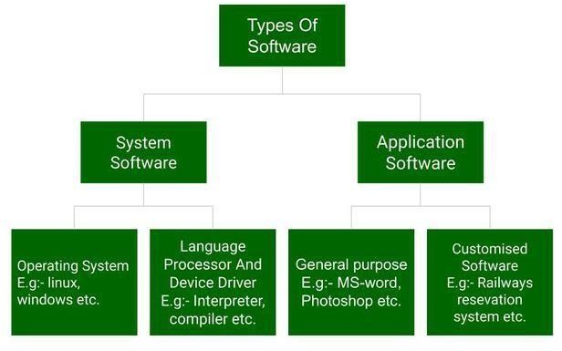

### Application Software

Application software is a generic term used for such types of software, which are used to solve a problem. The problem to solve is user specific. Word processors, computer games, database managers etc. are specific types of application of software.

### System Software

System Software are programs which are designed to operate, control, and extend the processing capabilities of the computer itself, e.g., operating systems, compilers, linkers etc.

These software’s sanction an environment or platform for the other software to easily work in. Hence, it is the reason the system software is quite important in the management of the entire computer system. Whenever you turn on the computer first, it is this system software which gets initialized and then gets loaded in the system’s memory. A system software essentially runs in the background, and it isn’t utilized by the end-users.

**Operating System**

Being a prominent example for system software, it is essentially a collection of software which handles resources as well as offers general services for various other application which run over them. There are different types of operating systems like embedded, real-time, distributed, single-user, multi-user, mobile, internet and much more. Full stack web development services develop apps to operate on a mobile operating system like Android and iOS. Some of the key examples of operating systems are as follows:

* 1. MS Windows
  2. macOS
  3. Linux
  4. iOS
  5. Android
  6. CentOS
  7. Ubuntu
  8. Unix

## Operating System

Operating System is a type of **System Software** and is a collection (set) of programs, which performs two specific functions. First, it provides a user *interface* so that human user can interact with the machine.

Second, the operating system manages computer resources.

## Computer Resources

Computer resources are physical devices, which an operating system accesses, and manages. Printers, memories, input/output devices, files, etc., are examples of computer resources. So why an operating is called a resource manager.

Some of important tasks, which a typical modern operating system has to perform, are given below:

* Processes Scheduling
* Inter-process Communication
* Synchronization
* Memory Management (physical memory allocation, virtual memory etc.)
* Resource Management
* Directory and File Management

# Types of Operating Systems

1. **Batch OS**

Old type, where tasks were executed in batches (no user interaction).

1. **Time-Sharing / Multitasking OS**

Allows many users/programs to run at the same time. Example: Windows, macOS, Linux.

1. **Real-Time OS (RTOS)**

Used where quick response is needed (robots, medical systems).

1. **Mobile OS**

Designed for smartphones and tablets. Example: Android, iOS.

### Linux

Linux is an operating system, which is a flavor of UNIX. Linux is a multi-user and multitasking operating system. It is a leading operating system on servers and other big iron systems such as mainframe computers and supercomputers. More than **90%** of today's 500 fastest supercomputers run some variant of Linux, Including the 10 fastest.

The Android system in wide use on mobile devices is built on the Linux kernel. Since with the likeness with UNIX, all the programs written for UNIX can be compiled and run under Linux. Linux operating system runes on verity of machines like 486/Pentium, Sun Sparces, PowerPC, etc.

Linus Torvalds, principal author, at the University of Helsinki, Finland, wrote Linux Kernel. UNIX programmers around the world in the development of Linux assisted him.

Popular Linux distributions include: RedHat, Debian, Ubuntu, Fedora, openSUSE, CentOS etc.

### Linux System

Linux System can be split into two parts.

* 1. Shell
  2. Kernel

Formally, a **Shell** is interface between a user and a Linux operating system, i.e. user interacts with the Linux operating system through the shell. There may be two tasks to be performed by a shell. First, accepts commands from a user and second, interprets those commands.

**Shell**

**Kernel**

Two shells, which are commonly used, are **Bourne shell (sh)** and **C shell**. One other shell, which is rather complex, is **Korn shell**.

Following list describes detail of each shell.

|  |  |  |  |
| --- | --- | --- | --- |
| **Shell Name** | **Developed by** | **Where** | **Remark** |
| BASH (Bourne-Again SHell) | Brian Fox and Chet Ramey | Free Software Foundation | Most common shell in Linux. It's Freeware shell. |
| CSH (C SHell) | Bill Joy | University of California (For BSD) | The C shell's syntax and usage are very similar to the C programming language. |
| KSH (Korn SHell) | David Korn | AT & T Bell Labs | -- |
| TCSH | See the man page. Type $ **man tcsh** | -- | TCSH is an enhanced but completely compatible version of the Berkeley UNIX C shell (CSH). |

**Kernel:**

**Kernel** is the core of Linux Operating System, while the system is operational, it keeps on running. The kernel is the part of the Linux Operating system which consist of routines, which interact with underlying hardware, and routines which include system call handling, process management, scheduling, pipes, signals, paging, swapping, the file system, and high-level part of the I/O system.

So, shell accepts commands from user interpret them and deliver these interpreted commands to kernel for execution. After execution, the shell displays result of executed commands.

## Files

File is a mechanism through which we store information. Normally, there are two modes of storing information.

1. File
2. Directories

### File

A simple file stores some type of information. The information it has may be in text format, or in binary format.

### Directories

**Directories** are special types of files owned the operating system, which contains information about files, and may contain other directories (called Subdirectories). So, directories are also files, which contains some vital information about the files, and other directories.

There’s a file (management) system in operating system, which manipulates file and directories. The major operations, which can be performed on files and directories, are given below:

* + Create
  + Delete
  + Open
  + Close
  + Read
  + Write
  + Append
  + Seek
  + Rename
  + Get Attributes
  + Set Attributes

### File Attributes

Since file contains some information about something, there’s needed some information about the file itself. This information about the file is called file attributes.

All operating system associates some extra information with each file, for example date and time of the file created, file size etc. These items are called file attributes. Some of file attributes are given below:

* + File type for example text, binary, etc.
  + File Name
  + Creator
  + Owner Current owner
  + Date created
  + Date last read access
  + Date last modified
  + Current size Number of bytes in the file
  + Maximum size Maximum size file may grow to.